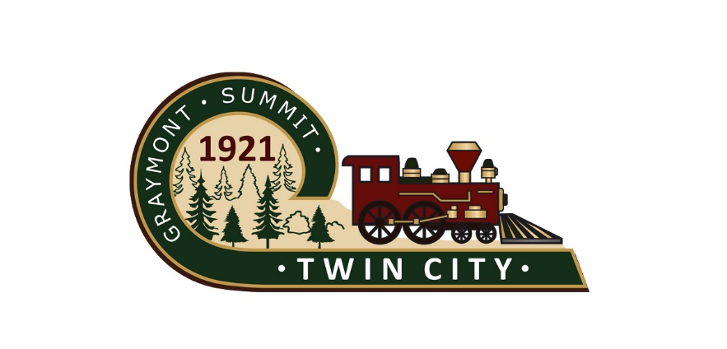
Public Notice
The Mayor and City Commission of the City of Twin City, Georgia will have a special called meeting on Monday, July 19, 2021 at 6:00PM. This meeting will be held at the Police Department in the City Commission Chambers. The purpose of the called meeting is to handle a personnel matter and consult with legal counsel.

Matt W. Donaldson, Mayor

